### Statistical Machine Learning Approaches to

### Liver Disease Prediction

**Team ID: PNT2022TMID08311**

**Faculty Mentor Team Leader:** Kavuri Swathi

T.Geetha **Team Member:** Jasthi Jyothi

**TeamMember:**Karumudi Meghana

**TeamMember:**Biridepalli Mounisha

**Build python code**

Python package builds are the product of coordination between a few different tools driven by a standardized process. One of the biggest choices you have as a package author is which set of tools to use. It can be difficult to assess the nuances of each, especially if you’re new to packaging. Fortunately, tools are standardizing around the same core workflow, so once you learn it you’ve got the agility to switch between tools with minimal effort This article covers what you first need to learn about the pieces of the Python build system itself.

**Importing Libraries**

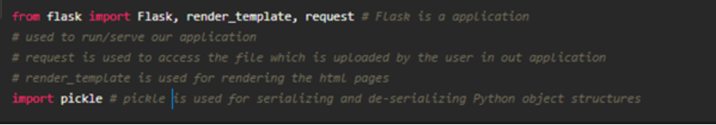

Libraries required for the app to run are to be imported.

Creating our flask app and loading the model



Now after all the libraries are imported, we will be creating our flask app. and the load our model into our flask app.

**Routing to the html Page:**

@app.route is used to route the application where it should route to.

‘/’ URL is bound with the home.html function. Hence, when the home page of the web server is opened in the browser, the html page is rendered. Whenever you enter the values from the html page the values can be retrieved using POST Method.

Here, “home.html” is rendered when the home button is clicked on the UI and “index.html” is rendered when the predict button is clicked.

Firstly, we are rendering the home.html template and from there we are navigating to our prediction page that is upload.html. We enter input values here and these values are sent to the loaded model and the resultant output is displayed on index.html.

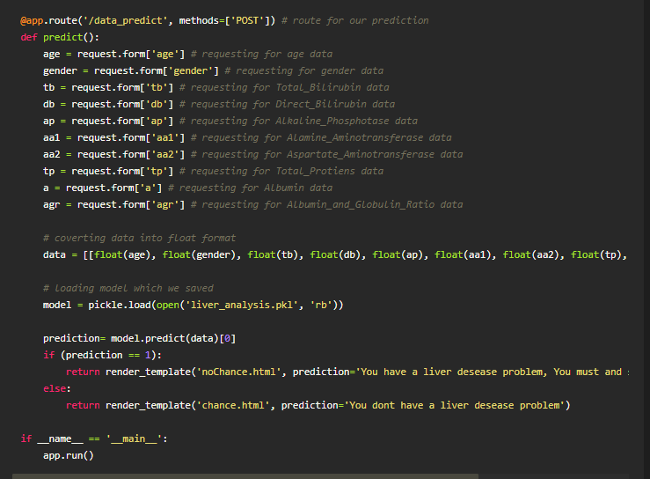

Here the route for prediction is given and necessary steps are performed in order to get the predicted output.

 Lastly, we run our app on the local host. Here we are running it on localhost:5000